SOCIAL MEDIA ANALYTICS
1. Social Media Analytics: An Overview
Core Characteristics of Social Media, Types of Social Media, Social media landscape, Need for Social Media Analytics (SMA), SMA in small & large organizations. Purpose of Social Media Analytics, Social Media vs. Traditional Business Analytics, Seven Layers of Social Media Analytics, Types of Social Media Analytics, Social Media Analytics Cycle, Challenges to Social Media Analytics, Social Media Analytics Tools
PAST QUESTIONS:
- Differentiate between social media analytics and Traditional Business Analytics. (M24)
- Explain the core characteristics of Social Media. (M24)
- Explain in detail the seven layers of social media analytics. (M24)
- Explain different Challenges for Social Media Analytics. (M24)
- Draw and explain the Social Media Analytics Cycle with a detailed description of each stage. (M25)
- Explain in detail the “Seven Layers of Social Media Analytics”. Also, discuss the tools commonly used for each layer with suitable examples. (M25)

NOTES:

*Core Characteristics of Social Media :-
Social media is an internet-based form of communication. Social media platforms allow users to have conversations, share information and create web content. There are many forms of social media, including blogs, micro-blogs, wikis, social networking sites, photo-sharing sites, instant messaging, video-sharing sites, podcasts, widgets, virtual worlds, and more.
Social media is defined by user-generated content, interactive digital platforms, and the ability to build networks for sharing, communicating, and collaborating in real-time. Key features include personal profiles, public or semi-public content sharing, and two-way interaction (likes, comments, shares)
Core Characteristics –
- User-Generated Content (UGC): The "lifeblood" of social media, where content is created, uploaded, and shared by users rather than professional producers.
Users create and publish content such as: Text posts, Photos, Videos, Stories, Comments and reviews
Users are both content creators and consumers.
- Interactive & Conversational: Supports real-time dialogue and interaction among multiple users (many-to-many communication) rather than one-way passive consumption. Social media enables two-way communication. Users can: Like posts, Comment, Share, React, Send direct messages. This creates active engagement rather than one-way broadcasting.
- Participatory & Socializing: Encourages active involvement through creating, commenting, and reacting, fostering community and social networking.
Social media connects people globally through: Friend requests, Followers, Groups, Communities. Users can build personal and professional networks.
- Openness and Connectivity: Enables rapid information sharing and access, breaking down geographical barriers to connect individuals and groups.
- Actionable & Measurable: Allows tracking user behavior, sentiment, and engagement (likes, shares) to analyze trends and drive marketing actions.
- Accessibility: Social media platforms are easily accessible through smartphones, tablets, and computers, allowing users to participate anytime and anywhere.
- Low Cost and Wide Reach: Creating and sharing content is usually free, enabling individuals and organizations to reach a large global audience at minimal cost.

*SMA vs TBA :-
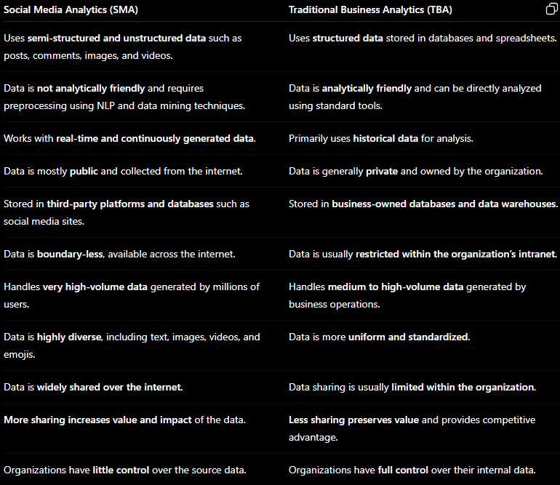
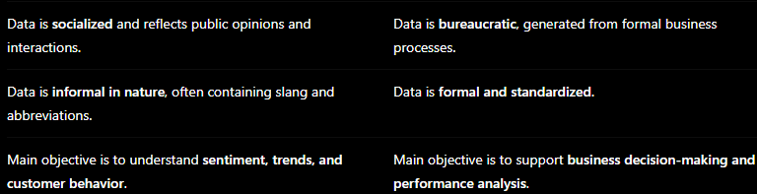

*Seven Layers :-
The seven layers of social media analytics include text, action, network, and hyperlink analytics. Others are mobile app, search engine, and location analytics. These layers form a system for marketers and data analysts to collect, organize, and analyze social media data.
Most marketers focus on metrics such as likes, shares, and impressions. But the smart ones dive deep into social media analytics to understand their audiences better. They use the seven layers of social media analytics to understand what consumers like, talk about, or feel. They then turn these insights into action in their content plans and campaigns.
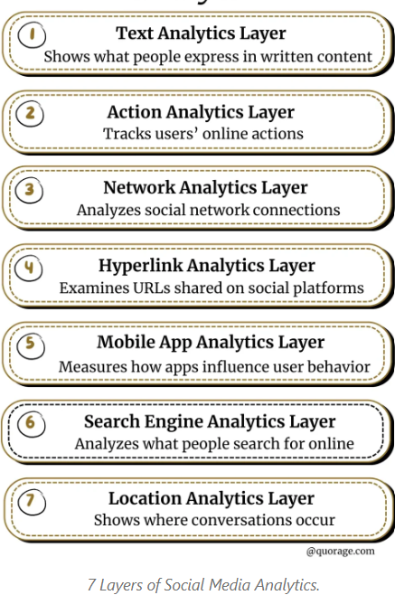
- Text – The text analytics layer tells you what people are saying in written content, it is also known as text mining because it extracts meaningful information from social media text.
This includes the content of social media posts, such as comments, tweets, blog posts, reviews, captions etc.
It is used to understand user sentiment and identify emerging themes and topics and help marketers to think ahead.
Tools used - Google Cloud Natural Language, IBM Watson Natural Language Understanding, NLTK, spaCy, TextBlob.
- Actions – This includes the actions taken by users on social media, such as likes, comment, shares and other interactions. It is used to measure popularity, influence and prediction in social media.
The action analytics layer tracks what people are doing online. It also measures and interprets what these actions mean in response to content.
Tools used - Meta Business Suite, YouTube Studio, X Analytics, Buffer Analyze
- Network – This includes the connection between users and the relationship between them, such as followers and friends on social media. It is used to identify influential nodes (people and organizations) and their position in the network.
Tools used - Gephi, NetworkX, NodeXL
- Hyperlinks – This includes the links between social media posts and other websites, as well as the content of those linked websites. It is used to reveal internet traffic patterns and sources of incoming and outgoing traffic.
Hyperlinks analytics analyze content distribution channels and external influence on your audience. Marketers and SEO experts track hyperlink patterns to know what sources audiences trust or promote.
Tools used - Ahrefs,, SEMrush, Moz Link Explorer
- Mobile – This includes data related to the use of social media on mobile devices, such as the type of device used, the operating system, and the location of the user. It is used to measure and optimize user engagement with mobile applications.
The mobile analytics layer measures how mobile apps shape users social behaviour. For instance, it tells you how users interact with content on apps. For example, most users visit social media platforms on mobile apps. So, understanding app usage helps shape platform specific strategies.
Tools used - Google Analytics for Firebase, Mixpanel, App Annie (data.ai)
- Search engine - This includes data on how users find and access social media content through search engines, as well as the keywords they use in their searches. It is used to analyze historical search data for trends analysis, keyword monitoring, and advertisement history.
It helps you spot search trends that matters to your business, SEO, It tells how many people searched for your brand.
Tools used - Google Search Console, Google Trends, Bing Webmaster Tools
- Location - This includes data on the geographical location of users and the location-specific content they engage with on social media. It is used to mine and map the locations of social media users, content, and data.
The location analytics layer or geo-analytics, tells you where conversations are happening. It offers helpful insight that help marketers target the right people and it’s a great way for businesses to offer or improve location-based services.
Tools used - Google Maps Platform, ArcGIS, QGIS

*Types of SMA :-
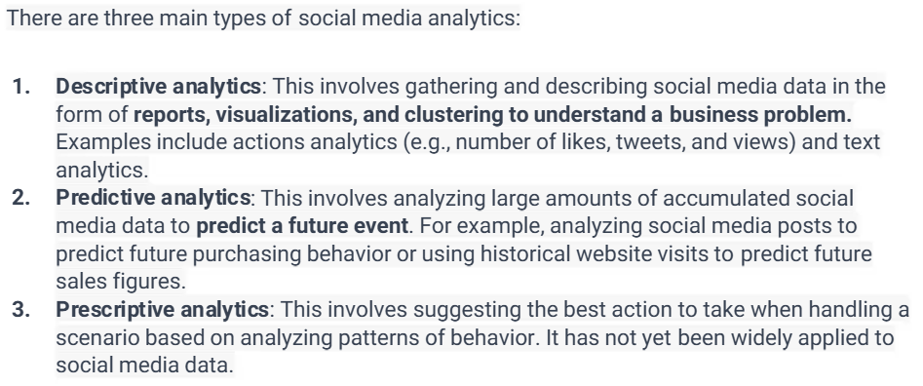

*SMA Lifecycle :-
The social media analytics cycle is an iterative six-stage process designed to turn raw social media data into actionable business insights. It involves identifying goals, extracting and cleaning data, analyzing and visualizing metrics, and interpreting findings to adjust strategy, ultimately ensuring efficient resource allocation and increased engagement.
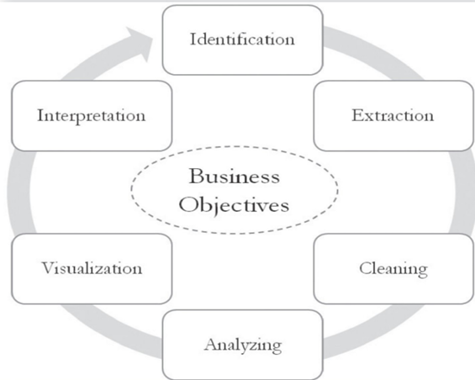
Step 1: Identification
- The identification stage is the art part of Social Media Analytics. It involves searching and identifying the right sources of information for analytical purposes.
- Social media contains huge amounts of data in the form of text, conversations, and networks. This data is diverse, multilingual, and noisy.
- Therefore, framing the right question and selecting the appropriate data source are crucial for obtaining useful business insights.
- The data selected for analysis should align with business objectives.
- Most data is collected from business-owned social media platforms such as official X (Twitter) accounts, Facebook pages, blogs, and YouTube channels.
Step 2: Extraction
- Once a reliable and relevant source of data is identified, the next step is extraction.
- The type (text, numerical, or network) and size of the data determine the extraction method and tools.
- Small datasets can be extracted manually.
- Large-scale data is usually extracted automatically using APIs (Application Programming Interfaces).
- Most social media analytics tools rely on API-based extraction.
- APIs are protocols provided by social media companies that allow users to access data stored in their databases.
Step 3: Cleaning
- This step removes unwanted and irrelevant data from the extracted dataset.
- Some datasets require extensive cleaning, while others may be ready for direct analysis.
- In text analytics, cleaning may involve:
  - Coding
  - Clustering
  - Filtering
  - Natural Language Processing (NLP)
- These tasks can be performed automatically by machines or manually by humans.
- The goal is to improve data quality and prepare the data for analysis.
Step 4: Analyzing
- In this stage, the cleaned data is analyzed to discover meaningful business insights.
- The analysis approach depends on the specific layer of social media analytics and the tools and algorithms used.
- For example, nodes in a social network may be clustered and visualized in different ways.
- The main objective is to extract insights while preserving data integrity.
- A good understanding of analytical tools and techniques is essential for obtaining accurate results.
Step 5: Visualization
- Analysis results are presented in visual formats for easier interpretation.
- Visual analytics plays an important role in interactive decision-making.
- Effective visualization helps reveal hidden patterns, relationships, and trends in large and complex datasets.
- Examples of visualizations include:
  - Word clouds
  - Hyperlink networks
  - Interactive maps
  - Charts and dashboards
- Visualization demonstrates the value of social media data to management.
Step 6: Interpretation
- Interpretation is the art part of Social Media Analytics.
- It involves translating analytical results into meaningful business insights.
- This step relies on human judgment, domain knowledge, and expertise.
- Interpretation is especially important in descriptive analytics, where results may have multiple meanings.
- Two approaches are commonly used:
  - Producing easy-to-understand analytical results.
  - Improving managers’ ability to interpret analytics.
- The final outcome is actionable knowledge for strategic decision-making.

*Challenges to SMA :-
Social Media Analytics (SMA) offers valuable insights for businesses and researchers, but analyzing social media data presents several challenges due to the unique characteristics of social platforms and user-generated content.
1. Massive Volume of Data: Social media platforms generate enormous amounts of data every second in the form of posts, comments, images, videos, and reactions. Processing and storing such large-scale data require powerful computing infrastructure and scalable analytics tools.
2. High Velocity of Data: Social media data is created continuously in real time. Analytics systems must process incoming data quickly to detect trends, monitor events, and support timely decision-making.
3. Variety of Data Formats: Social media contains structured, semi-structured, and unstructured data, including text, images, videos, audio, emojis, and hashtags. Integrating and analyzing such diverse data types is technically complex.
4. Unstructured and Noisy Data: User-generated content often contains slang, abbreviations, spelling mistakes, sarcasm, and informal language. This makes it difficult for analytical tools to accurately interpret meaning and sentiment.
5. Multilingual Content: Users communicate in multiple languages and dialects. Developing models that can understand and analyze multilingual data accurately is a major challenge.
6. Limited Data Access: Social media platforms restrict access to data through APIs, rate limits, and changing policies. This can limit the quantity and quality of available data.
7. Interpretation of Results: Analytics outputs require domain knowledge and human judgment to convert findings into meaningful business decisions.
8. Data Quality and Veracity: Misinformation, spam, bot-generated content, and missing data points make it difficult to trust the accuracy of the analytics.
9. Sentiment and Sarcasm Detection: Understanding human emotions, sarcasm, irony, and context remains difficult even for advanced Natural Language Processing (NLP) systems.
10. Data Fragmentation: Data is scattered across multiple platforms (LinkedIn, Instagram, TikTok), making it difficult to create a unified dashboard or a holistic view of performance.

